All students have google drive installed on their computers; however, in order for google drive to appear in File Explorer when they are saving things, they first need to find google drive in the start menu and set it up by entering in their school email address and password.

Step 1:
Have students click on the windows icon in the lower left and just type out google drive.
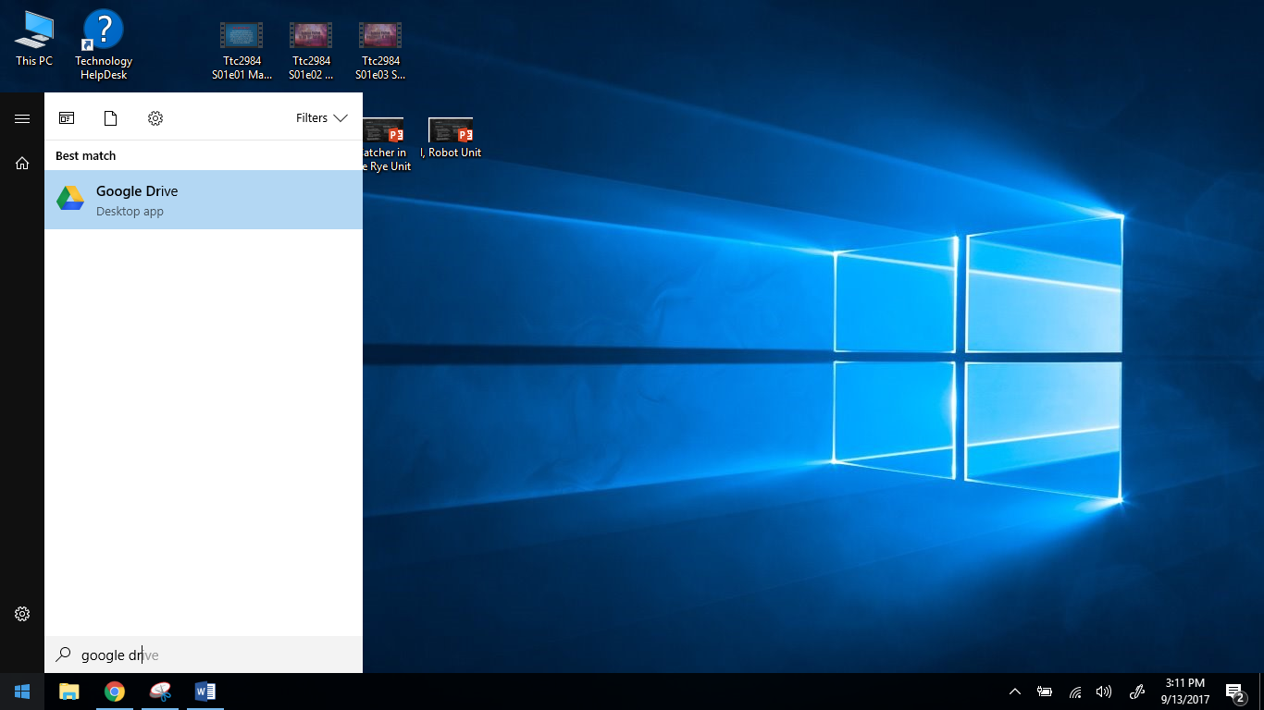
Type “google drive”

Step 2:
Click on the menu item called “Google Drive Desktop app” that appears.
Step 3:
When prompted, enter your k12 email and password.
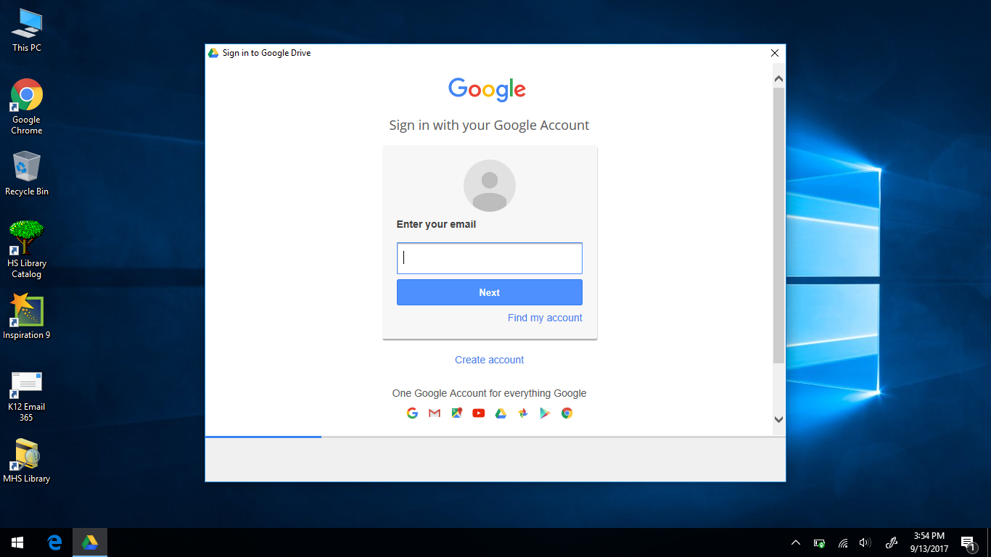
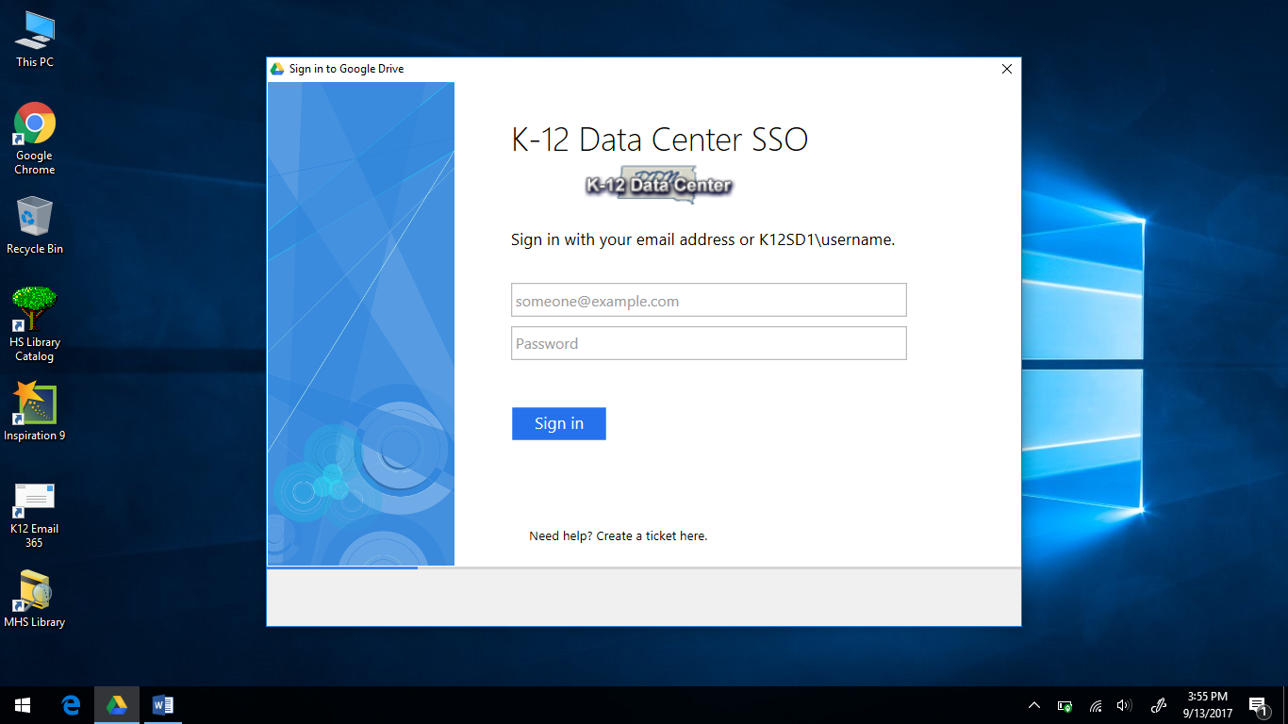
Step 4:
Click next through the welcome wizard. Click done when the wizard is finished explaining the features of Google Drive.
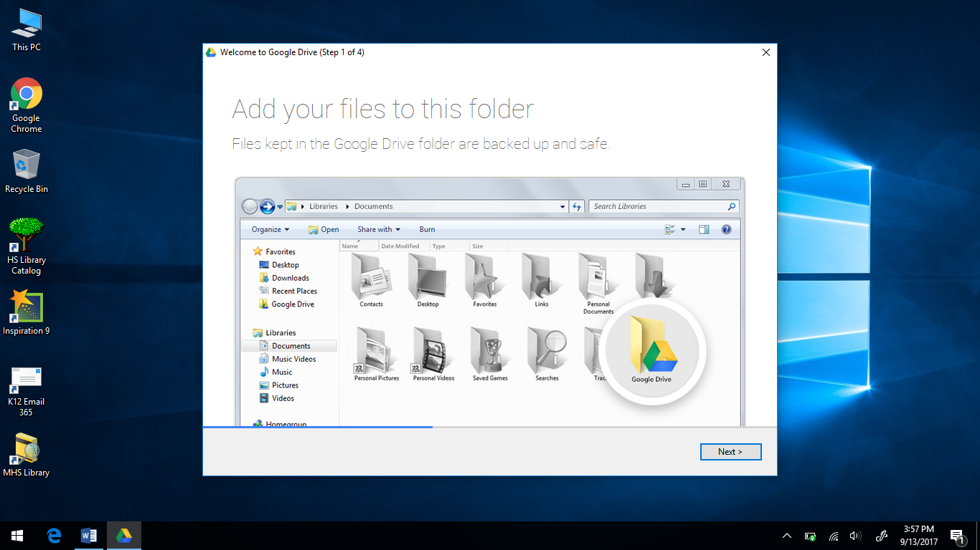 | 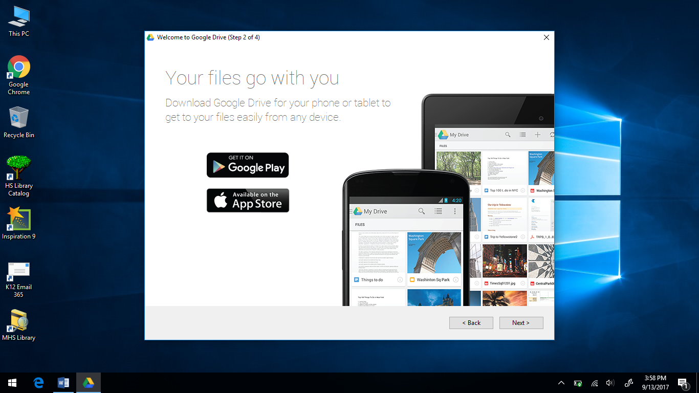
 | 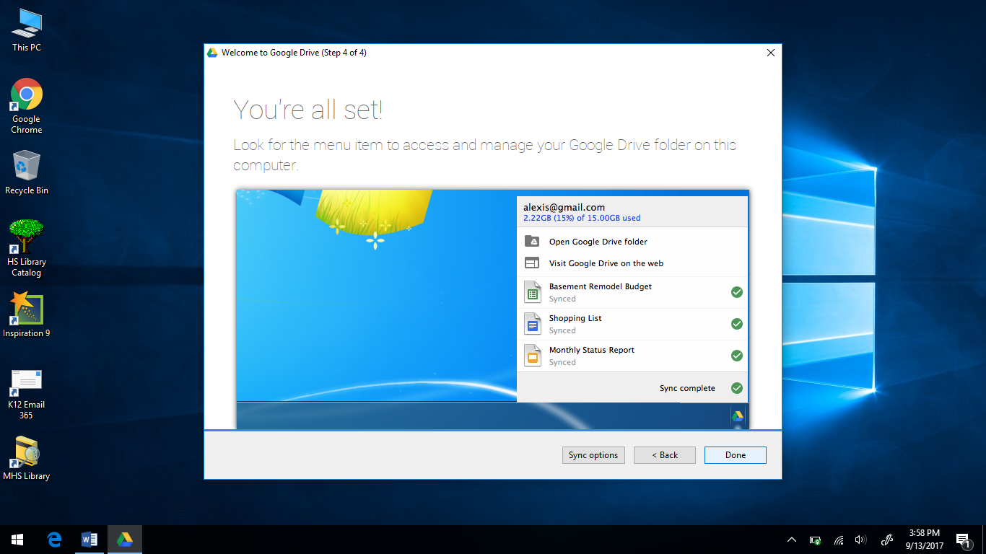

Step 5:
When saving files in the future, choose Google Drive from the available drives in the File Explorer under the “quick access” links.
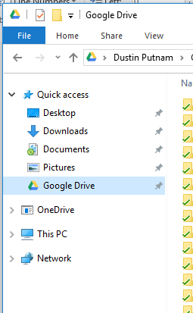 | 